Whole School Food Policy
Westminster Children’s University

1. Purpose of Food Policy
This policy has been written to give clear guidance to staff, outside visitors, parent and carers, and pupils about the provision of food during the school day and our approach to the positive promotion of healthy eating. Good food provision in schools has been shown to lead not only to healthier children, but to improved attainment.

2. Food and Drink Provision Throughout the Day
2.1 Food Standards for Schools, maintained nurseries and nursery units attached to schools
As part of the School Food Plan, a new set of standards for all food served in schools was launched by the Department for Education. These standards are mandatory for all maintained schools. All academies and free schools are also expected to comply with these standards, and since 2014 is an explicit requirement within funding agreements.
These school food standards are intended to help children develop healthy eating habits and ensure they obtain the energy and nutrition they need across the whole school day, which includes food provided for breakfasts, mid-morning snacks, lunch, tuck shops and after school clubs.

The standards do not apply to:
- Parties or celebrations to mark religious or cultural occasions
- Fund raising events
- Rewards for achievement, good behaviour or effort
- For use in teaching food preparation and cookery skills, including where the food prepared is served to pupils as part of a school lunch
- On an occasional basis by parents or pupils
- Food and drinks provided after 6pm, or during weekends or school holidays

For more information please refer to:
- The DFE Standards for School Food in England (updated 2021) https://www.gov.uk/government/publications/standards-for-school-food-in-england
- The DFE School Food Standards – Resources for schools including a practical guide, checklists , portion sizes and allergy information (updated 2021) https://www.gov.uk/government/publications/school-food-standards-resources-for-schools
- The School Food Plan – provides a range of resources including recipes ideas, portion sizes and learning from others https://www.schoolfoodplan.com/

For maintained nurseries and nursery units attached to primary schools there is a reduced set of standards for food served at lunchtime. Each day, food from each of the categories below must be provided as part of the school lunch:
- Fruit and vegetables (fresh, frozen, canned or dried)
- Starchy foods (bread, pasta, noodles, potatoes, sweet potatoes, yams, millet and cornmeal)
- Meat fish and other non-dairy sources of protein (meat and fish in all forms, plus eggs, pulses and beans)
- Milk and Dairy (milk, cheese, yoghurt, fromage frais, custard)
In addition, for maintained nurseries and nursery units’ whole milk, rather than lower fat milk, may be provided. Children under 2 years should only be offered whole milk. Fresh clean free drinking water should also be available for children every day. Very young children in nursery should use a free-flow cup for drinking. Staff should also be aware of serving appropriate portion sizes for children and encourage them to stop eating when they are full.

Maintained nurseries and nursery units are encouraged to consider enhancing their menus to meet the ‘Eat Better Start Better Voluntary Food and Drink Guidelines for Early Years Settings’. For more information please refer to: https://www.foundationyears.org.uk/wp-content/uploads/2017/11/Eat-Better-Start-Better1.pdf

2.2 Breakfast
Breakfast is an important meal and contribution towards energy requirements and is an opportunity to provide essential vitamins and minerals.
- For information on the school food standards for breakfast please refer to: https://assets.publishing.service.gov.uk/government/uploads/system/uploads/attachment_data/file/996114/Checklist_for_school_food_other_than_lunch.pdf
- For information on breakfast guidelines for maintained nursery schools and nursery units attached to schools please refer to the Eat Better Start Better guidelines page 36 and 37: https://www.foundationyears.org.uk/wp-content/uploads/2017/11/Eat-Better-Start-Better1.pdf

Breakfast is served once and are provided by Westminster Children’s University
We provide the following foods/drinks at breakfast
- A variety of fresh fruits
- A selection of fortified low sugar cereals. We mix plain cereal with wholegrain varieties to reduce overall sugar content. We offer porridge and other high fibre cereals.
- A variety of different types of bread including wholegrain varieties. We choose bread and bread products with a low or medium salt content.
- A variety of different toppings for toast and bread e.g. low fat spread, low fat soft cheese, We offer reduced sugar jam occasionally.
- Semi-skimmed milk for drinking and/or with cereal and low fat (and lower sugar) dairy products such as yoghurt (lower in fat and sugar, plain and unsweetened) or cheese. Or whole (full fat) milk for children aged from 1-2 years.
- Fresh drinking water

2.3 Snacks
Snacks can play an important part of the diet of children and young people and can contribute positively towards a balanced diet. Snacks provide an opportunity to have 1 of your 5-a-day, as well as include other important nutrients in the diet.
As part of the School Food Standards, schools are only able to provide fruit, vegetables, nuts and seeds as a snack. Dried fruit should not be offered as a snack, and should only be offered at mealtimes within a meal/dessert. The Government’s school fruit and vegetable scheme entitles all children in KS1 to one piece of fruit and / or vegetable per day.
- For more information on snack guidelines for schools please refer to: https://assets.publishing.service.gov.uk/government/uploads/system/uploads/attachment_data/file/996114/Checklist_for_school_food_other_than_lunch.pdf

For more information on snack guidelines for schools please refer to: https://assets.publishing.service.gov.uk/government/uploads/system/uploads/attachment_data/file/996114/Checklist_for_school_food_other_than_lunch.pdf

For maintained nursery schools and nursery units attached to primary schools only, the Eat Better Start Better guidelines recommend that each snack for 1-4 year olds includes:
- A starchy food e.g. toast, pitta bread, rice cakes. With a variety of at least 3 different varieties of starchy food across snack each week.
- Fruit or vegetables as part of some snacks. With a variety provided across the day and week
- No dried fruit, cakes, biscuits or confectionary
- Beans, pulses, fish, eggs, meat or other protein may be provided as part of snack once or twice a week
- Dairy and alternatives. It is best practice to provide three portions of milk and dairy foods each day. One of these can be provided as part of snacks.
- A meal or snack is offered to children at least every 1.5 – 3 hours. This is because children have small stomachs and high nutrition needs as they grow and develop.

For information on snack guidelines for maintained nursery schools and nursery units attached to schools please refer to the Eat Better Start Better Guidelines page 38 and 39: https://www.foundationyears.org.uk/wp-content/uploads/2017/11/Eat-Better-Start-Better1.pdf

Provide details of how snacks are organised at the school:
- Westminster Children’s University provides additional snacks during the school day during breaks
- Children are allowed to bring in snacks from home to eat at school which are healthy. Westminster Children’s University works hard in providing guidance for parents/carers on healthy snacks verbally and in leaflets/letters.
- Westminster Children’s University serves 1-4 year olds snacks attending the nursery to meeting the Eat Better Start Better guidelines?

2.4 School lunches
The school lunches meet the statutory school food standards. Lunch is served at 12:30 and is provided by: Westminster Children’s University or Sourced through Local Partners
In September 2014, the Government introduced universal free school meals for all children from Reception to Year 2.

Provide details of how the school ensures:
- The quality of ingredients for lunches is ensured by careful checking and analysis of each food offer in conjunction with food planned that project duration.
- Students feedback with parents about each project’s food offer which shapes the next. Parents / carers are encouraged to opt for school lunches for their children and are encouraged to do so.
- The Westminster Children’s University lunches meet the statutory school food standards.
- All meat is Halal

For maintained nursery schools and nursery units attached to primary schools only, the Eat Better Start Better guidelines recommend that lunches include:
- One lunch that only uses pulses or meat alternatives as the protein source for all children
- Restricts the use of pastry to once a week
- Providing small portion sizes on child sized plates. This is because it is better for children to ask for seconds than to serve them too much.
- Children are not praised for finishing the food on their plate. This helps children to recognize when they are hungry and when they have eaten enough.

For information on lunch guidelines for maintained nursery schools and nursery units attached to schools please refer to the Eat Better Start Better Guidelines page 40 and 41: https://www.foundationyears.org.uk/wp-content/uploads/2017/11/Eat-Better-Start-Better1.pdf

2.5 After school clubs
For information on the school food standards for after school clubs please refer to: https://assets.publishing.service.gov.uk/government/uploads/system/uploads/attachment_data/file/996114/Checklist_for_school_food_other_than_lunch.pdf

We provide the following foods/drinks at after /additional Project Provision
- A variety of different fresh fruits and fresh vegetable sticks
- A variety of toast and waffles and a choice of toppings including low fat spread, beans or cheese.
- Steamed rice and vegetables
- Milk
- Low fat yoghurts

Schools cannot provide the following foods for after school club

https://www.foundationyears.org.uk/wp-content/uploads/2017/11/Eat-Better-Start-Better1.pdf

2.6 Drinks
Water is available for all pupils throughout the day, free of charge. Children are able to refill water bottles easily and are actively encouraged to drink water regularly throughout the day.
Lower fat milk is available for children at least once a day in addition to before and after school clubs.
Whole milk can be provided for pupils up to the end of the school year in which they reach age 5, after that, milk must be lower fat. You may choose to offer lower-fat milk (e.g. semi skimmed milk) from the age of 2 years, providing the child is growing well.
(In addition, choose one option and delete the others from your policy)
We only provide drinks that are unsweetened, unfortified and additive free. The only other drinks provided at school and offered only to children aged 5 or older are:
- Fruit or vegetable juice (maximum portion size of 150mls per day)
- Plain soya, rice or oat drinks enriched with calcium; plain fermented milk (e.g. yoghurt) drinks
- Combinations of fruit or vegetable juice with plain water (still or carbonated, with no added sugars or honey) - maximum portion size 330mls. They may not contain added vitamins or minerals, and no more than 150mls fruit or vegetable juice. Fruit or vegetable juice combination drinks must be at least 45% fruit or vegetable juice.
- Combinations of fruit juice and lower fat milk or plain yoghurt, plain soya, rice or oat drinks enriched with calcium, cocoa and lower fat milk; flavoured lower fat milk, all with less than 5% added sugars or honey - maximum portion size 330mls. They may not contain added vitamins or minerals, and no more than 150mls fruit or vegetable juice. Fruit or vegetable juice combination drinks must be at least 45% fruit or vegetable juice.
- Tea, coffee, hot chocolate.
We do not provide any other drinks including squash, flavoured water, soft drinks and fizzy drinks and smoothies due to the sugar content, preservatives, colourings, flavourings and sweeteners.

3. Menu Development and Consultation
Our Project, Westminster Children’s University, engages with key stakeholders before implementing any menu changes and these include:
- Healthy Schools Lead
- Catering company/provider including the catering company nutritionist/dietitian
- Parents / carers
- Catering staff at school including chefs and lunchtime supervisors
- Person responsible for budgeting
- Teacher and teaching assistant representation
- Your local HSL contact as required
- (Add any other relevant services e.g. Change4Life)

Our project, Westminster Children’s University, ensures that the pupil’s voice is heard when reviewing our food and drink provision. The group that represents our pupils is called (enter name of group e.g. the School Nutrition Action Group (SNAG) / School Council). We actively encourage children from different backgrounds to join this group.

4. Food and Drink brought into school and parent engagement
4.1 Packed lunches
We encourage parents to provide healthy well balanced packed lunches.
For children aged 5 years and above preparing a healthy well balanced child’s lunchbox, includes:
- Starchy foods – these are bread, rice, potatoes, pasta etc
- Protein foods – including meat, fish, eggs, beans etc
- A dairy item – this could be cheese or a yoghurt
- Vegetables or salad
- A portion of fruit
- A healthy drink such as water or milk

INCLUDE:
- Minimum of 1 portion of fruit and 1 portion of vegetables everyday
- Meat, poultry, fish and non-dairy protein e.g. pulses
- Oily fish at least once every few weeks (e.g. sardines, salmon)
- Starchy food such as bread, pasta, rice, potatoes including wholegrain varieties
- A dairy product milk, cheese and yoghurt (unsweetened, low/medium sugar) and low/medium fat for children aged 5+, any dairy alternatives should be unsweetened and fortified
- Water or milk (semi-skimmed or skimmed).

LIMIT:
- Processed meat products sausage rolls, pies, sausages etc
- Cakes and biscuits to be enjoyed as part of a meal occasionally not as a snack
- Fruit juice: no more than 150mls per day (restricted to children aged 5+)

DO NOT INCLUDE:
- Salty snacks such as crisps, nuts etc
- Sweets and chocolate
- Sugary soft drinks

For more information and practical tips for children aged 5 years and above: https://www.nhs.uk/healthier-families/recipes/healthier-lunchboxes/

For children, aged 1-4 years old, preparing a healthy packed lunch includes:
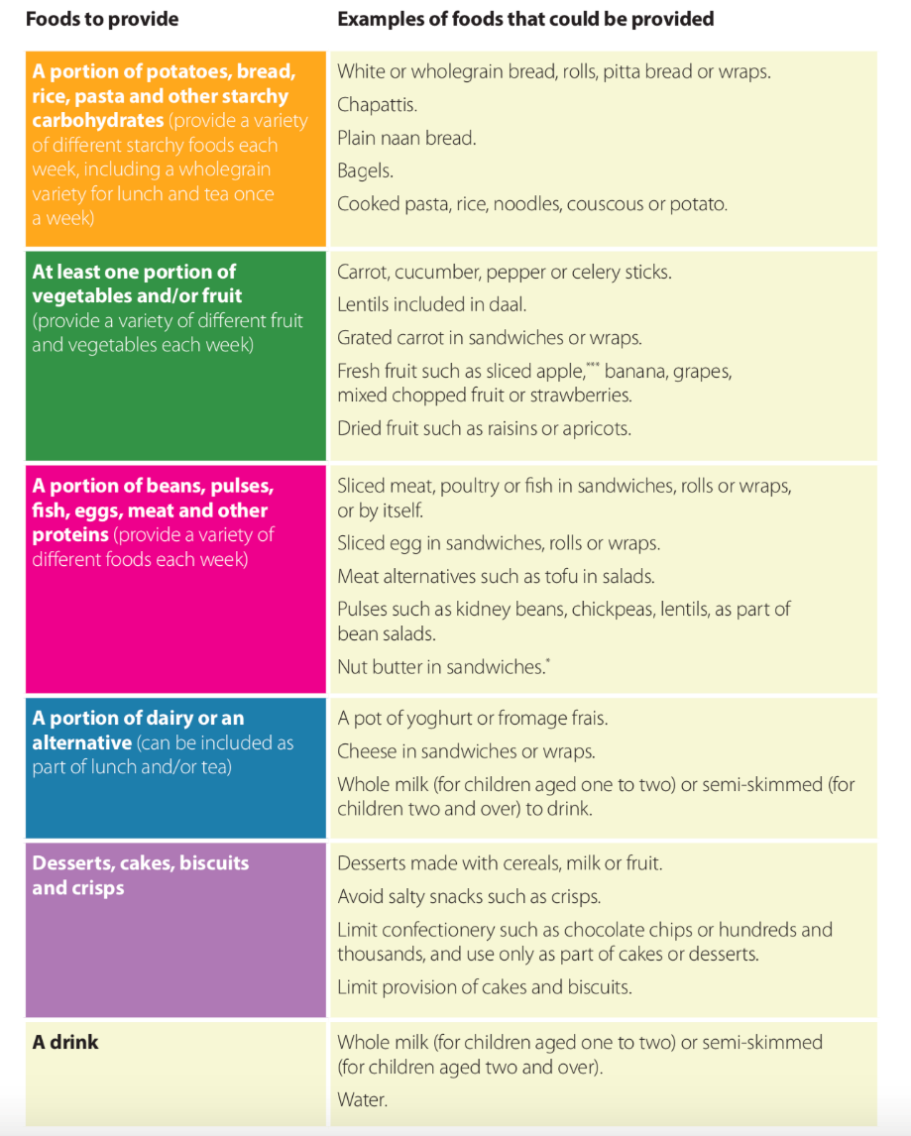

For more information and practical tips for children aged 1-4 years old: https://static1.squarespace.com/static/59f75004f09ca48694070f3b/t/5a926d288165f549b5a68ca2/1519545646246/Packed_lunches_Dec17.pdf

Special Dietary Requirements
We are aware of food allergies / intolerances and other dietary requirements of children and have procedures in place to identify and manage these, including (Provide details of the procedures that you have in place to identify and manage the dietary requirements of):
- Religious and ethnic groups
- Vegetarians and vegans
- People with food allergies and intolerances (guidance here)
- People with medical conditions where dietary needs are impacted

Staff have completed the following training to enable them to manage food allergies, intolerances and dietary requirements:
- First Aid
- Adrenaline / anaphylactic shock training
The Dining Experience
Good quality eating environments significantly increase the uptake of school food. We have done the following to ensure that we have a pleasant eating environment for children:

9. Food Safety
We ensure food safety at all stages of food preparation and storage, including:
- Adequate facilities, suitable equipment, risk assessments and hazards identified.
- Ataff training (e.g. all staff hold Level 2 food safety certification)
- Additional food safety measures for younger children is understood and adhered to https://www.nhs.uk/conditions/baby/weaning-and-feeding/childrens-food-safety-and-hygiene/ and refer to notes within the Eat Better Start Better document https://www.foundationyears.org.uk/wp-content/uploads/2017/11/Eat-Better-Start-Better1.pdf

Cooking and Food Education in the Curriculum
Teaching pupils how to cook is an important part of our whole school approach to health and wellbeing. It captivates and stimulates pupil’s interest and enjoyment of food as well as building self-confidence.

The school follows the National Curriculum which states that healthy eating, nutrition and cooking must be taught in Science, Design and Technology (D&T), and Health Education.
For more information please refer to:
- Design & Technology - https://www.gov.uk/government/publications/national-curriculum-in-england-design-and-technology-programmes-of-study/national-curriculum-in-england-design-and-technology-programmes-of-study
- Science – https://www.gov.uk/government/publications/national-curriculum-in-england-science-programmes-of-study/national-curriculum-in-england-science-programmes-of-study
- Health Education - https://www.gov.uk/government/publications/personal-social-health-and-economic-education-pshe/personal-social-health-and-economic-pshe-education
Food, cooking, food growing, and nutrition education is taught in Westminster Children’s University projects actively by:
- Ensuring food and nutrition is taught at an appropriate level throughout each key stage.
- Identifying food and nutrition links to different subject areas e.g. PE, RE, Geography, History
- Addressing this through different teaching methods; leading by example, staff training, visitors to the classroom, resources etc.
- Ensuring that staff understand their role of promoting healthy eating messages in the school environment e.g. that all staff are informed about the policy, are given sufficient training so that they can teach and work effectively with pupils, liaise with external agencies and caterers, monitor teaching and learning about healthy eating, and act as positive role models.
- Monitoring pupils’ learning.
12. Monitoring and Evaluation
- Recording of offer and reporting to Ben Commins ,Lyndsy Killip and Mellissa Royale will monitor and evaluate how this policy is upheld
- Newsletters, parent’s evenings, staff meetings etc. will help inform all stakeholders of the policy and how it is being implemented.
- Menus and media to be widely shared online, in reports and on display.
- Feedback to be collected and reported after each project

13. Policy Review

Policy Implementation Date: September 2022
Next Review Date:September 2023
Signed: S Wilson Manager
Date:

