We’re Going on a ‘University Adventure!’
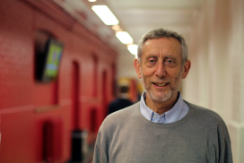
Michael Rosen, children’s champion and famous author of ‘We’re Going on a Bear Hunt’ is set to open the latest Children’s University in a successful network.
On Monday 20th February, Michael Rosen, newly appointed Chancellor of Westminster Children’s University will officially launch this exciting new project at Queen’s Park Primary school and across a number of schools in Westminster.
The Children's University is a national organisation that provides 5 to 14 year olds with exciting and innovative learning activities and experiences outside normal school hours.
Raising children's aspirations is important and the aim is to develop the understanding that learning can be 'a satellite navigation to better places in life'. The ethos of the Children's University is one of cooperation, collaboration, learning from each other and making things better for children and young people through providing and facilitating aspirational high quality learning experiences that can act as a satellite navigation system to better places in life.
Investment from the University of Westminster means that all children accessing 30 hours plus of extracurricular activities will gain stamps in their Children’s University passport and will graduate in front of peers, teachers and family – with our first graduation being held in February 2018.
With the launch of a new website Westminster Children’s University already has over 600 members, who will be able to share in a number of partnerships already established.
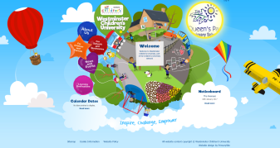
A number of high profile events during the opening weeks, include workshops and book signings by ‘Feel Brave’ author Avril McDonald, sporting tours and competitions from Queen’s Park Rangers and collaboration with the local library and sports centres compliment a mini lecture series from a wide range of industry professionals. 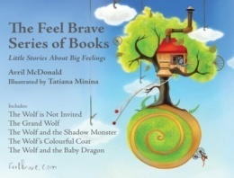 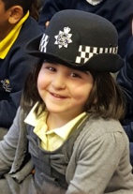
@CU_Westminster

For further information please contact:
Lyndsy Killip (deputy@queensparkschool.co.uk)
Tel: 0207 641 5860
# # #
For more information about the wider Children's University network, contact Liam Nolan, Head of Communications and Stakeholder Engagement for Children's University Trust (Reg charity no. 1118315). 0161 907 5390 and liam.nolan@childrensuniversity.co.uk

