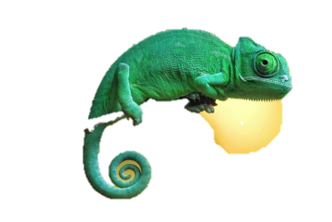
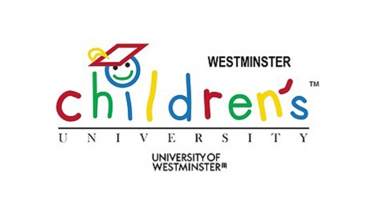
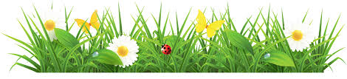

WE LIKE WHY!
Info Pack for Parents


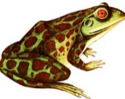

Sign up for WE LIKE WHY, a free 10 week After School Science project for children in Year 3 and 4 as a part of the Westminster Children’s University. The project includes:
10 After school Sessions for your Y3 or Y4 child  - Mon 23rd April – Environmental Studies  - Mon 30th April – Chemistry  - Mon 14th May – Zoology: Ornithology  - Mon 21st May – Zoology: Entomology  - Mon 4th June – Zoology: Entomology  - Mon 11th June – Botany  - Mon 18th June – Human Biology  - Mon 25th June – Human Geography  - Mon 2nd July – Global Issues  - Thurs 12th July – Zoology: The Bees | 3 Family Fun days for your whole family  Sunday 22nd April @ The Floating Classroom from 11am-1pm  Monday 28th May (Half Term) @ The Natural History Museum 11am onwards  Sunday 15th July @ The Floating Classroom 10am til 2pm – A boat trip celebration to Camden and back!
See the next page for location details. Please contact Floating Classroom Lead Teacher Maya Bell Kohli for any further information.
Return the sign up form ASAP to reserve a spot!


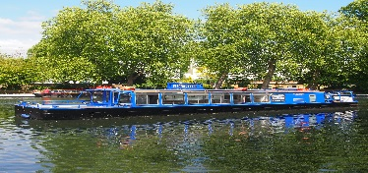
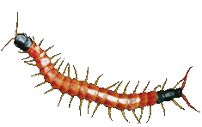
Have a look at our website www.thefloatingclassroom.co.uk for more info about what we do!
Please bring a packed lunch for the whole family to each family fun day!
Maya’s Contact Details

Tel: 07852 975214

Email: mayabellkohli@thefloatingclassroom.co.uk

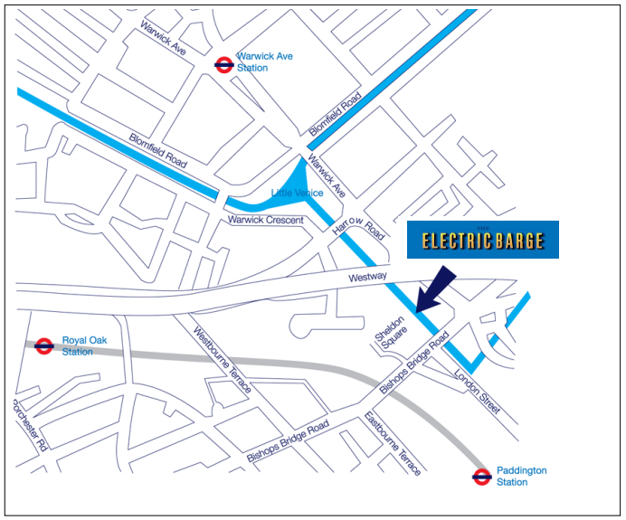
We are next to Sheldon Square, Paddington, London W2 6NA
For help with directions on the day call Maya on 07852 975214

Project Overview We Like Why – After-School Science for Y3/4

The Floating Classroom, a creative charity based on a boat in Paddington, is collaborating with the Westminster Children’s University (WCU) to bring you a fantastic new after-school science project called We Like Why. There will be:
- 3 x Family fun days – bring your parents, carers, brothers and sisters.
- 10 x After-School sessions for Years 3 and 4
- A ‘Home play’ activity each week to continue learning and have fun with new knowledge
- The chance to get out and explore the local area while bringing scientific ideas to life!

Family Day 1 -Sunday 22nd April | Welcome to the Floating Classroom!  Come with your family for a fantastic boat trip that brings science to life! We’ll investigate properties of slime, let off some rockets and even make bath bombs to take away.  Suitable for all ages. | 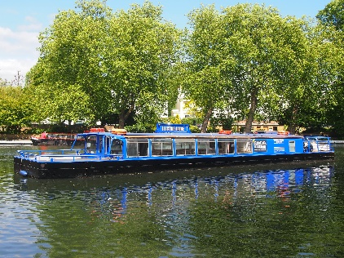
Session 1 –  Monday 23rd April  Environmental Studies | Discovering Nature in the City (and our Homes)  We think of often think of nature and the city as opposites – today, we investigate the crazy ways in which the two support each other! We’ll go on a habitat hunt to spot the animals that call the man-made world home and have a look at some of the ways in which humans are trying to bring the natural world back into the city. We’ll consider how insect life is a vital part of the world around us and have a look at some of the creatures that live alongside us in our homes – including spiders! We’ll make a house for a spider to take away. | 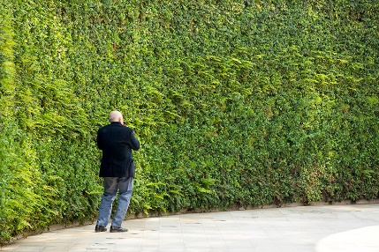

Session 2 –  Monday 30th April  Chemistry | Wonderful Water  Water is vital for life on earth! In fact, water covers 70% of the planet! Today, we’ll investigate the water cycle and learn about its importance for humans. We’ll also find out what is living in the water around the canal and what we can learn about the environment from looking at what’s in the water. Our session wouldn’t be complete without an awesome demonstration of how water can change state through the magic of ‘sublimation’. | 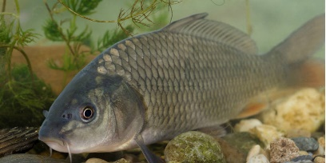
Session 3 –  Monday 14th May  Zoology: Ornithology | Birds and their Habitats  Today we’ll take a closer look at some of the most fascinating animal life around the canal – the birds! We’ll be super scientists working out facts about how birds live and what they eat by looking at how their beaks, feet and feathers are adapted to suit their environments. We’ll learn about some common birds found in London and make bird feeders to take away so that our scientific observations can continue at home. | 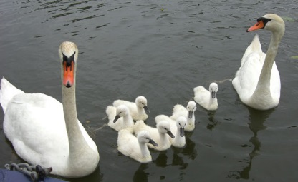
Session 4 –  Monday 21st May  Zoology:  Entomology | Minibeast Madness  Today we look at some of the smallest creatures around us in their natural habitats. This session will be based at Meanwhile Gardens, where we’ll go on a minibeast hunt! We’ll develop our scientific skills by using classification keys to help identify and group our findings. Times are changing for the bug life around us – we’ll examine how climate change might be affecting the bugs we find in the UK. To help us continue our learning at home, we’ll make a bug hotel to take away. | 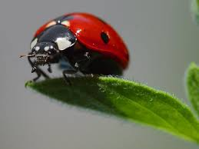
Family Day 2-  Wb Monday 28 May – Half Term Week | Natural History Museum Visit  Today, bring your whole family for a fun filled day with Tim and Maya at the Natural History Museum. We’ll explore the ‘Investigate’ exhibit together and visit the butterfly house. Suitable for all ages. Please bring a packed lunch. | 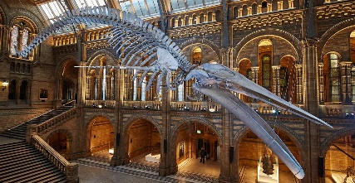
Session 5 –  Monday 4th June  Zoology:  Entomology | Creepy Crawlies  This week we’ll continue our learning on the bizarre world of bugs – but this time, we’ll have some international guests on board the boat! We’ll examine some creepy crawlies from around the world and learn more about how classify a range of creatures. We’ll compare our finding on bugs from the UK to bugs from around the world – including South America, Africa and Asia. | 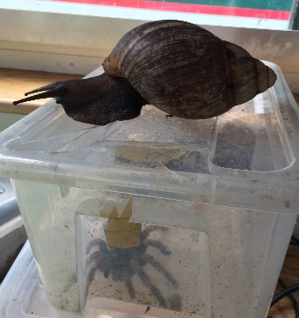
Session 6 –  Monday 11th June  Botany | Plant Power  As humans, our lives depend on plants. At Meanwhile Gardens we’ll be Plant Detectives hunting for plants that can defend themselves from danger in weird and wonderful ways. We’ll also look at the function of each part of a flowering plant through a flower dissection. Finally, we’ll make a ‘plant postcard’ that will show us the truly amazing diversity of plants – no plant is quite the same as another! | 
Session 7 –  Monday 18th June  Human Biology | The Story of Digestion  You’ve heard a grown up say ‘you are what you eat’ – we investigate this claim today! We’ll map the journey of food through your body and find out more about what we should (or shouldn’t!) be eating and why. We’ll also look at how the advertising affects the choices we make about food – can you really tell the difference between the brand and the supermarket products? Put your taste buds to the test! | 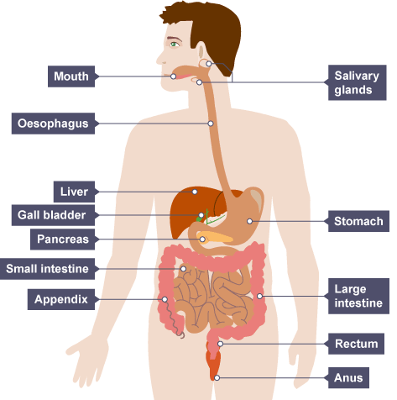
Session 8 –  Monday 25th June  Human Geography | What a Waste  Last week we talked about human waste and this week we’ll consider where human waste goes.  History of the sewer system. We’ll use drama to bring to life the unhealthy conditions of the canals 200 years ago and learn about how London life today depends on our sewage system. We’ll also learn about the life of landfills – what really happens to the things in the bin?! Make your own mini landfill to take away. We’ll also learn about the magic of composting – why is it so important for the planet and what can go in it? Make sure you save that banana peel, because you’ll be conducting your own compost experiment at home. | 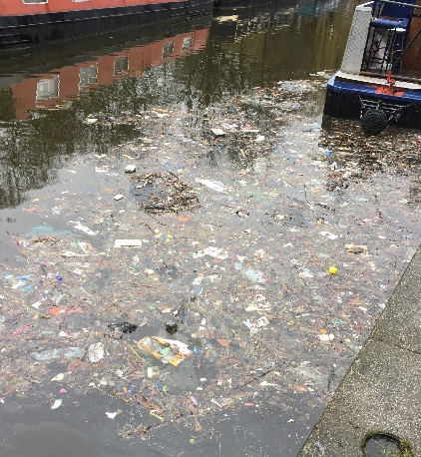
Session 9 –  Monday 2nd July  Human Geography | The Problem of Plastic  Today we turn our attention to something the whole planet needs – a solution to plastic pollution! We’ll begin by learning how plastic became a worldwide phenomenon and debate the good and the bad points of this most widely used material. We’ll explore the canal and spot the plastic pollution around us before learning more about which plastics can be recycled and how. We’ll experiment with one plastic that really does dissolve in water – but what are the downsides? Finally we’ll make sure once and for all that you know which materials belong in that recycling box. | 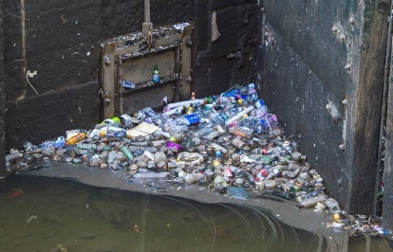
Session 10 - Monday 9th July  Zoology:  The Bees | Small Means Big: The Bees  We all know honey is sweet, but did you know that there are different flavours? Find out why in our honey taste test! We’ll also find out more about the busy life of a bee, it’s a hard worker indeed. We’ll play our pollination game to find out why the bees matter so much and then take a trip to meet a real beekeeper and see some working beehives! You won’t bee-lieve your eyes! | 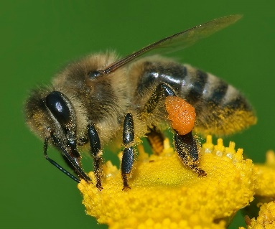
Sunday 15th July  Family Day 3 | Celebration Day  Bring your whole family to the boat to celebrate all your amazing discoveries. We’ll have art and craft activities as we cruise around the canal and a creepy crawly or two will join us on the boat. Relax and enjoy the end of the project together. | 

