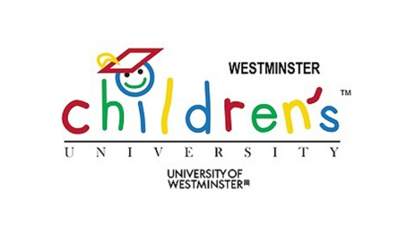

New Beginnings:
Transition to Secondary School Project

The Floating Classroom has been funded by the Young Westminster Foundation to deliver ‘New Beginnings’, a project for Year 6 children to build resilience as they transfer to Secondary.
We would like to offer 4 free places to students at your school that you think would particularly benefit. Overall, 20 children from 5 different schools from the Westminster Children’s University will take part. Students taking part in New Beginnings will gain credits towards their WCU Degrees.
What we are offering:

A chance for students explore what matters to them as they say goodbye to their current school and move towards new experiences. Sessions will include mindfulness, yoga and movement and group problem solving – as well as a boat trip! Children will learn techniques to manage their mental health positively and will take the lead in offering each other support and advice. Our aim is that they finish the project more excited about the notion of change and confident about the new opportunities that lie ahead.

Timings – 10am to 2pm each day

- Wednesday 6th June Session 1: New Beginnings – Children will meet each other and play ice breaker games as we travel on the barge.
- Monday 11th June Session 2: All About Me - This session will explore what it is about them that might matter as they go forwards – what are their particular talents and strengths?
- Monday 18th June Session 3: Friends and Family - We explore the relationships they have, the new ones they might make and what role these relationships play in their lives at secondary school.
- Tuesday 26th June Session 4: Old and New School – What are the advantages and disadvantages of leaving your school? What will be required of them in the new school context and what resources, skills and supports can they use to meet these challenges?
- Tuesday 10th June Session 5: Saying Goodbye - We end our project with a celebration of all the children have achieved. The first half will explore children’s concerns about endings – what makes an ending hard (if it is) and what helps when it’s challenging? What do you take with you as you move on? We’ll invite children’s parents and teachers to the boat to celebrate with them and have a party to round off our time together.
What we need from you:
- Relevant background information/learning needs of the children you have selected to take part.
- A teaching assistant to drop off and pick up the children from the boat for each session (they are welcome to stay if possible).
- ANYTHING ELSE TO ADD HERE SR?


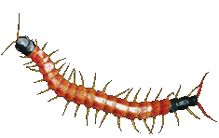
Contact Details
Tel: 0203 214 3118
Email: mayabellkohli@thefloatingclassroom.co.uk
simon.ryder@thefloatingclassroom.co.uk
Please contact us by
Wednesday 23rd May to book! spaces

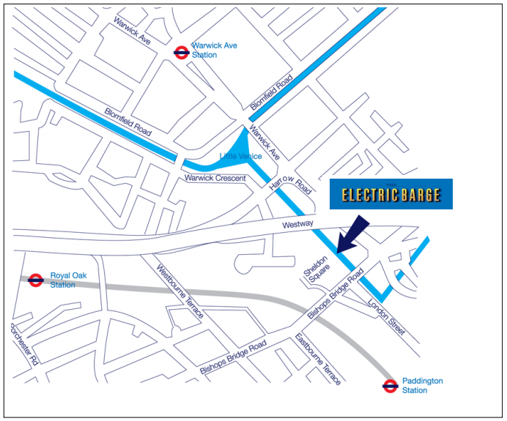

We are next to Sheldon Square, Paddington, London W2 6NA

For help with directions on the day call Maya on 07936655570



