We Like Why

Our after-school science project, We Like Why, is back! It’s a free 10-week project that will see Children’s University students take part in hands-on scientific learning on the Floating Classroom, in the green space of Meanwhile Gardens and on the bee terrace of Victoria’s St Ermin’s Hotel.
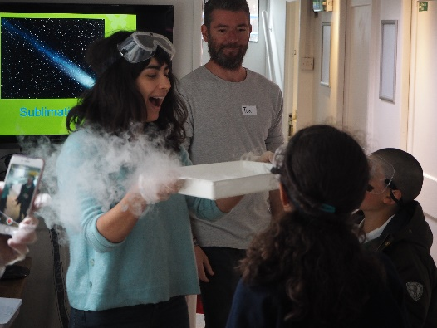
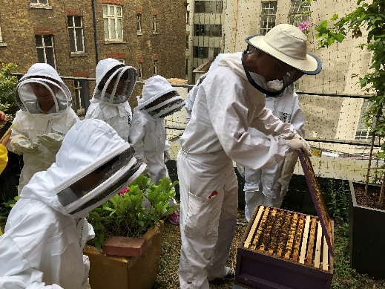

Designed specifically for Years 3 and 4 students, the sessions will take place from 4-5:30pm on the following dates in the summer term:

- Tue 30 April – Discovering Nature in the City - Environmental Studies
- Tues 7 May – Wonderful Water - Chemistry
- Tues 14 May – Birds and their Habitats - Zoology: Ornithology
- Tues 21 May – Minibeast Madness - Zoology: Entomology
- Tues 4 June – Creepy Crawlies - Zoology: Entomology
- Tues 11 June – Plant Power - Botany
- Tues 18 June – The Story of Digestion - Human Biology
- Tues 25 June – What a Waste - Human Geography
- Tues 2 July – The Problem of Plastic - Global Issues
- Tues 9 July – Small Means Big: The Bees - Zoology

In addition, we’ll be hosting two family fun days at the start and end of the project – details below:

- Sun 28 April 11am – 1pm – an opportunity for parents to find out more about the project and while there to get involved with making bottle rockets, slime and bath bombs. All in the name of science!
- Sun 21 July 10am -1pm – end-of-project celebration with families joining us for a trip along the Regent’s Canal from our mooring near Paddington Station

We only have space for 20 students to take part in We Like Why so to book your place please complete the sign-up form and hand it in to your class teacher.

