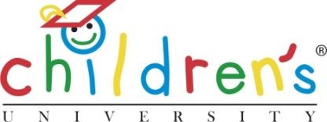
Children’s University (CU) Trust
124 Oxford Road
Manchester
M13 9RD
United Kingdom
Tel: +44 (0)161 907 5389
Email: helen.odonnell@childrensuniversity.co.uk
Web: www.childrensuniversity.co.uk

What is a Learning Destination?

Learning happens all the time in lots of different places, at different times and in different ways.
Children’s University (CU) Learning Destinations are places and organisations to which children can ‘travel’ with their Passport to Learning and which provide high quality learning opportunities and activities with a ‘wow’ factor.
Known as Learning Activities, these experiences have passed the CU’s own quality assurance process (Planning for Learning). This ensures that the quality of learning available at our Learning Destinations is consistently high worldwide, and that all Learning Activities connect with studies you can undertake at a university.
There are two types of CU Learning Destination:
Public Learning Destinations are places which provide CU Learning Activities and which are publicly accessible. This includes locations such as wildlife centres, zoos, historical interest sites, theatres and libraries.
We have an ever-increasing number of Public Learning Destinations across the UK and internationally to which children can travel with their Passport To Learning. Public Learning Destinations can also be based online and involve completing online courses or challenges. For these partners, we host Learning Activity packs on the CU website and link passport holders to the partner’s website.
Restricted Learning Destinations are places which are not publicly accessible. This includes school-based clubs and societies, uniformed organisations, and clubs which require local membership. Participating in such groups, or carrying out certain activities within them, can be counted towards a child’s Passport To Learning.
Alongside these more traditional learning opportunities, Restricted Learning Destinations can also be found in the workplace. Such Learning Destinations are arranged by our local CU centres, working with hospitals, hotels and newspaper offices to list just a few examples.
There is a nominal fee associated with becoming a CU Learning Destination.


Quality Assurance
In becoming a CU Learning Destination, all organisations are asked to undertake our quality assurance process as we must be sure that there is a consistent quality to the Learning Activities in which our CU learners participate.
This validation forms part of our process of self-evaluation and planning known as Planning for Learning - A Framework for Validating Learning, devised with the support of Professor John MacBeath of the University of Cambridge.
CU Validation does not require the completion of an excessive amount of paperwork. It works best when time is set aside to talk about potential learning opportunities and to explore them through the eyes of the children they are designed to engage. This allows us to be confident that, wherever a CU learner chooses to access a CU Learning Activity, their experience will be a positive one and that the learning will be engaging, creative and fun!
The benefits of becoming a CU Learning Destination
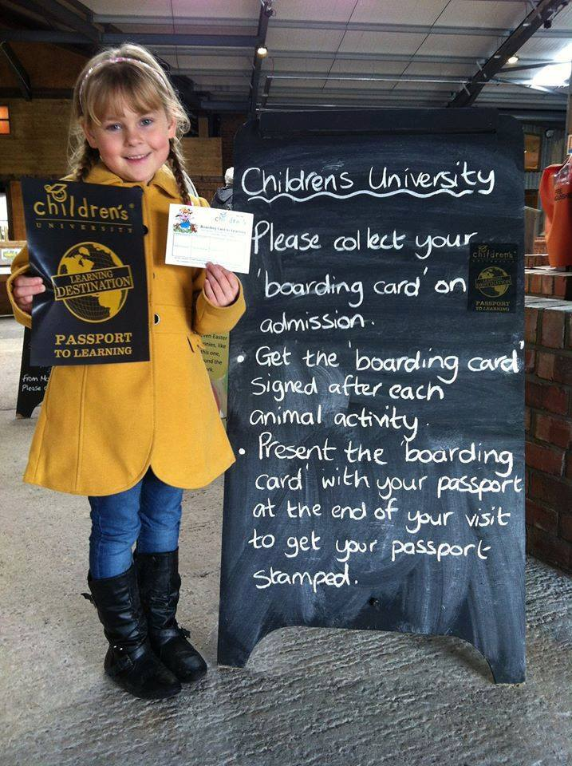
CU Learning Destination status tells children that a visit to your organisation will provide them with good quality learning.
Our experience has shown that becoming a CU Learning Destination encourages first time visits for many children and their families who go on to return. More visits for you, more stamps for the Passport to Learning.
Once confirmed as a CU Learning Destination, we ask that you display our Learning Destination logo prominently inside and outside of your learning environment so that it is clearly visible to visitors and children who may wish to use their Passport To Learning.
Your CU Learning Destination status will also give you access to our nationally recognised Learning Destination logo for use. We would encourage you to display the Learning Destination logo on all literature and letter headed paper and to display our logo on your website and social media sites, linking directly to the CU website too.

Health and Safety, Public Liability and Safeguarding
It is important to note that, whilst CU Validation assures the quality of the learning opportunities offered, matters of Health and Safety, Public Liability and Safeguarding remain the responsibility of the learning provider. All Public Learning Destinations are expected to operate to their statutory requirements in these areas and to declare that they do so.

Becoming a Learning Destination Partner
A number of our learning partners are large organisations with many sites nationwide, each of which acts as a Learning Destination.

Working with these national Learning Destination partners ensures that there is great diversity in the type of learning offered and the organisations with which we are working.
If your organisation fits such a profile and you are interested in becoming a CU Learning Destination, a member of the CU Trust team will be happy to discuss with you the learning opportunities that you offer.
If your organisation is, instead, based at a single location, please contact your local CU Manager, who will support you in identifying which of the activities you provide would make you eligible to become a CU Learning Destination. You can find their contact details on our website (www.childrensuniversity.co.uk). If your CU Manager is not able to help you, please contact CU Trust.
To speak to a member of the CU Trust team, please call 0161 907 5389 or email contactus@childrensuniversity.co.uk.

