
Children’s University (CU) Trust
124 Oxford Road
Manchester
M13 9RD
United Kingdom
Tel: +44 (0)161 907 5389
Email: helen.odonnell@childrensuniversity.co.uk
Web: www.childrensuniversity.co.uk

Using the Passport To Learning: Guide for Parents and Carers

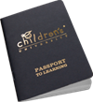
Introduction
We are delighted your child has become a member of the Children’s University (CU). We have provided the following information to help you and your child get the most from their involvement. It is important to remember that participation in Learning Activities must be voluntary, and take place outside the normal school day and at a Learning Destination. You should find that all CUs operate within these broad guidelines, but with some scope for locally agreed flexibility.

Who stamps the Passport To Learning?
Your school co-ordinator will oversee this for school-led Learning Activities. We encourage children to take responsibility for handing in their Passport To Learning when asked. Activities need not be added separately each week – most schools update the Passport To Learning half-termly or termly. At Public Learning Destinations, a child’s Passport To Learning should be stamped by the learning provider. If this is not possible, school co-ordinators can add hours if given proof of participation.

What Learning Activities count?
Learning Activities must take place outside the normal school day, so at before-school, lunchtime and after-school clubs, and during weekends and holidays. Only activities at Learning Destinations that have been quality assured by us can be included. Schools will ensure children know which clubs are included. Public Learning Destinations can be found via our website.

How do I recommend an activity?
We welcome suggestions for new Public Learning Destinations. Most CUs have a simple form for parents and children to make recommendations. The validation of Public Learning Destinations is managed through the local CU Manager, and depending on their capacity, this may take a little time. If you are interested in training as a volunteer validator, please contact your local CU Manager.

Who decides how much time to include for each activity?
A recommended range, or set number, of hours is attached to each Learning Activity. Our key principle is that the hours included relate to learning within an activity, and will not necessarily include the whole session. As an example, a Youth Club meeting lasting 2 hours may only count as 1 hour of learning if some time is given over to socialising.

What about regular clubs and activities outside of school?
As well as signposting new activities, we also want to encourage children to become resilient and persevere with an activity they are good at. Regular participation in validated uniformed organisations, sports clubs and teams, music practice and performance can all be included in the Passport to Learning. To maintain the breadth of learning, individual clubs or groups should account for no more than 30 hours in any one school year, or 10 hours per school term.

Individualised and on-line learning programmes
Whilst we want to promote opportunities for children to learn together, we also recognise the benefits that children take from learning as individuals. As with the examples above, these activities are limited to 30 hours in any one school year, or 10 hours per school term.
How do I support my child to include a range of activities?
Encouraging children to try new activities and unfamiliar experiences, and promoting independence in learners is a key principle of CU. Within any award there should be a mix of activities, with no more than a third spent on a single activity. For example: A 30 hour CU Award could be made up of:
- 10 hours of Swimming Club activities (practice, competitions, coaching)
- 4 hours of Brownies (Badgework is the main focus of learning)
- 10 hours of school clubs (e.g. Chess, Cookery)
- 6 hours of music (tuition, practice, performance)

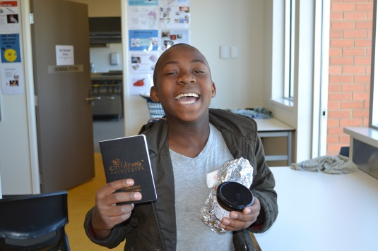
How can my child take part if their school is not a member of Children’s University?
Some local CUs have the capacity to offer individual Child Membership to children who are not able to join through their local school. This ‘open’ membership enables children to use their Passport To Learning at Public Learning Destinations or any locally organised CU Learning Activities.
The charge for Child Membership is determined locally. As well as their Passport To Learning, children will be given an online E-Passport which must be used together with the Passport To Learning to enable the CU Manager to track participation and issue invitations to a CU Graduation Ceremony.

How does the passport work with Home Educated children?
Home Educated children can use their Passport To Learning in the same way, with the obvious exception of school-based Learning Activities. In keeping with the CU principles of encouraging collaborative learning beyond the ‘classroom’, parent-led, home-based activities for individual children cannot be validated.
Learning Activities can be validated if provided for groups of children, up to a maximum of 30 hours on a single activity in any one year. For example:
Sarah is home educated and attends a Mad Science Learning Activity, alongside other Home Educated learners, for 2 hours each week. Whilst Sarah may participate, over the course of 30 weeks, in 60 hours of Mad Science activities, a maximum of 30 hours can be counted towards a CU Award in any one Membership year.

What about activities with faith organisations?
CU Learning Activities must be open to all, and we do not include in the Passport To Learning instructional classes based on adherence to a single faith. Where activities are voluntary, open to those of all faiths and none, and encourage children to explore faith and beliefs more broadly, they may be considered for validation.

How does Children’s University work with Supplementary Schools?
Activities offered through Supplementary Schools, provided they are open to children of all cultures, can also be considered for inclusion in the Passport To Learning.

Where can I find further information?
Your local CU Manager is the best person to answer any other questions which you may have regarding the Passport To Learning. Please contact your child’s school (if they are a CU school) in the first instance, or your local CU Manager. You can find their contact details on our website (www.childrensuniversity.co.uk). If your CU Manager is not able to help you, please contact CU Trust at contactus@childrensuniversity.co.uk.

