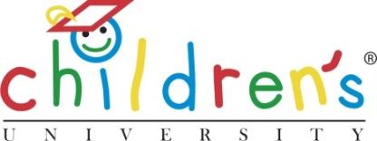
Children’s University (CU) Trust
124 Oxford Road
Manchester
M13 9RD
United Kingdom
Tel: +44 (0)161 907 5389
Email: helen.odonnell@childrensuniversity.co.uk
Web: www.childrensuniversity.co.uk

What is the Children’s University?

Described by the Sunday Times as ‘The University of Fun’, Children’s University (CU) is a critically acclaimed programme which takes education far beyond the confines of the classroom.

Established in 2007, we work with children to ignite their passion for learning, build their self-confidence and demonstrate the real world relevance of school subjects. This breaks the cycle of underachievement which prevents many children from realising their full potential.

Children can only aspire to what they know and we want every young person to expect more for their future, to be aware of the options available to them, and to be confident that, whichever direction they choose, they can make a success of it.

How does Children’s University work?

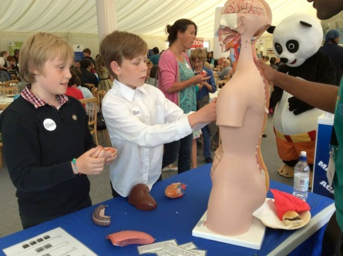
Registered children are presented with a wide range of Learning Activities delivered by myriad partners called ‘Learning Destinations’. These partners include museums, sports associations, local businesses and afterschool clubs to name but a few.

Activities are held out of school hours, be that before or after school, during lunchtime or during the holidays, and range from imaginative, child-friendly lectures on topics such as ‘the chemistry of fireworks’ to street dance workshops and reading challenges.

Each learning experience is accredited against our robust quality assurance framework, ‘Planning for Learning’, ensuring that learning offered anywhere across the CU network is of the same high standard, irrespective of location or subject area.


Recognition of effort and achievement is central to the programme’s success. Each time a child completes a Learning Activity they receive a stamp, or credit, in their CU ‘Passport to Learning’. One hour of learning equals one credit. Sufficient earned credits earn CU Certificates of Achievement across 3 levels: undergraduate, postgraduate and fellowship.

Awards are presented at CU Graduation ceremonies held locally each year, at either a partner university or a prominent civic building, such as a town hall. The ceremonies are closely modelled on the ‘grown up’ version, replete with caps and gowns and parents watching proudly in the audience.

What support structure is available?

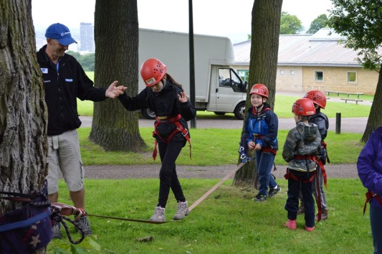
One of CU’s unique selling points is its localised management structure found across the British Isles and beyond. It operates a membership model to keep overheads low and to harness local expertise. CU Trust (registered charity 1118315) manages and directs the programme, providing ongoing support to local partners as well as developing innovative new Learning Activities.

Partners are not-for-profit organisations with proven track records of working with children. Typically, partners are an HE/FE institution, an academies trust, a children’s/education charity or a schools collaborative. This set up ensures that CU is positioned at the very heart of the communities in which it operates and is able to react to local changes rapidly, whilst still providing personalised learning.

Who benefits from Children’s University?

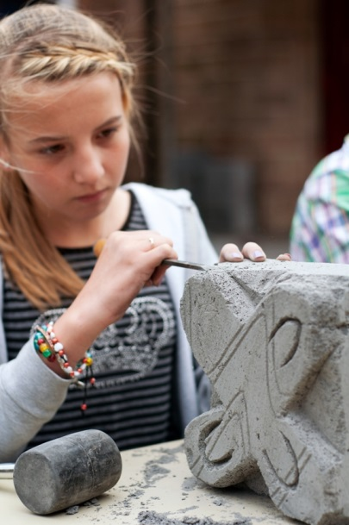
Unlike more traditional programmes, CU deliberately targets children from a far younger age (5-14) thereby challenging negative attitudes before they become entrenched. As participation is entirely voluntary, children will learn to take control of their own progress and learning.

CU is open to all children, irrespective of background, as everyone benefits from better exam results, a broader skillset, new interests and a greater awareness of future education/career options. Financial resources, however, are heavily targeted towards children from the most disadvantaged families and communities as this is where support is needed most.

For schools and academies, CU provides opportunities to further engage students and to support their most vulnerable children. Key findings of the programme’s work through independent national evaluation show that CU positively impacts upon the following: Attendance; Attainment; Achievement; Attitudes; Adventure; Awards; Agency; Aspiration; Adaptability; and Advocacy.

What difference does it make?


It is well known that formative experiences heavily shape future life choices, particularly in relation to education and employment. Independent evaluation carried out by the University of Cambridge has confirmed that participation in CU - and the wide array of activities offered through the programme - significantly improves school attendance, increases levels of attainment across all ages and raises aspirations.

CU builds confidence and nurtures critical life skills such as the ability to work as part of a team, effective communication, resilience and use of initiative. These are all attributes highly prized by employers. Finally, CU motivates young people to get involved in positive out-of-school activities, significantly reducing the likelihood of them participating in negative/anti-social behaviour now or in later life.

