Rainbow Acrostic
You can use our template to write an acrostic using your name or something that makes you happy, then paint a lovely bright rainbow for all to see when they are on their isolation walks.
This is a simple, fun activity that the whole family can get involved in. Once they are ready, you can stick them up in your window to share with your community.

Examples
All of us together in the house
Love spending time together
Finding fun things to do
I am really enjoying it
Even though I miss school!
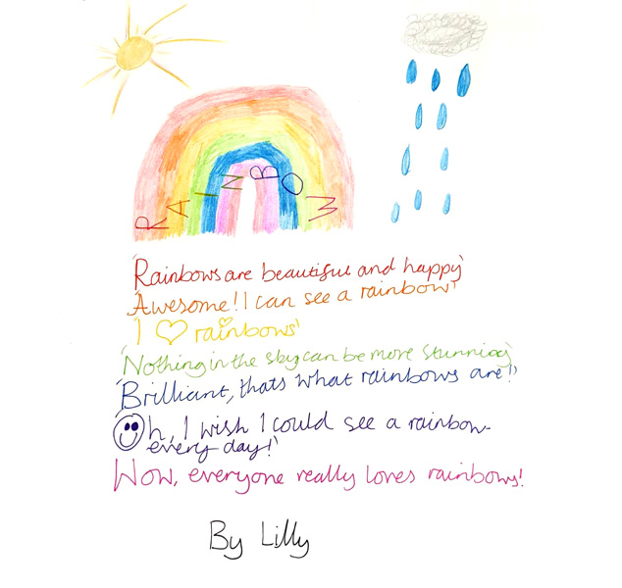

What To Do
Writing an acrostic is fun and easy, here are the simple steps:
1) Print the template off this page or get some plain paper. Write your name down the left hand side of the page.
2) Use the first letter of each line to start each sentence; once you have done this for each line, your poem is complete.
3) Colour in or paint the rainbow at the bottom of your page and then showcase it in your window for all to see.
You can do one of these for each member of the family...it’s fun to write and draw together!
Writing Portal
Download Template

Contact Details
Write To Unite
Remus House
Coltsfoot Drive
Peterborough
PE2 9BF
info@writetounite.co.uk

Socials

Our

