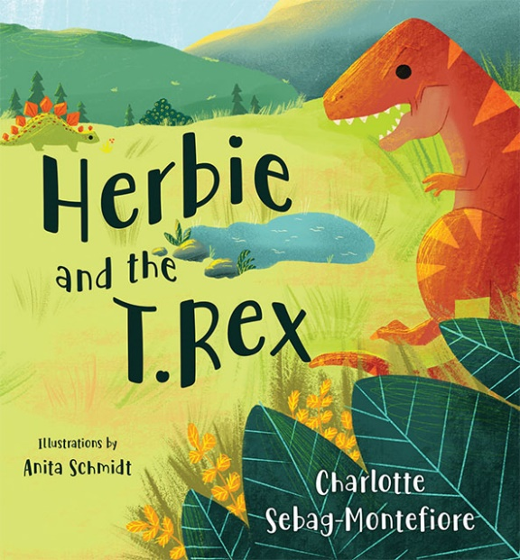
Herbie and the T. Rex
By Charlotte Sebag - Montefiore
Published by Olympia Publishers
26-03-2020,
£4.99, Paperback,
ISBN: 978-1-78830-497-9

A dinosaur story with all the hallmarks of a bedtime classic plus a modern twist! Meet Herbie and his dino friends; but watch out, a terrifying T. Rex is creeping about! A beautifully illustrated story about friendship that children and adults will find fascinating.

Charlotte Sebag-Montefiore's third book, is a new departure for her into the fascinating world of dinosaurs. Charlotte says that her interest in dinosaurs springs from what they have in common with us, - for some were bipeds, and the fate of all hinged on climate change.
Anita is an illustrator based in northern Germany. With her family she lives in a small town by the sea. All her inspiration comes from this environment. After studying designs and working in the advertising industry, she got back to her life-long passion for drawing and illustrating.

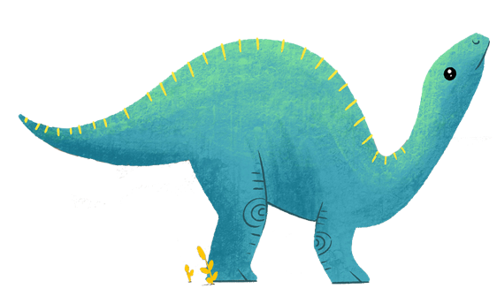

Press Contact: publicity@olympiapublishers.com
Tel: 02037553166

