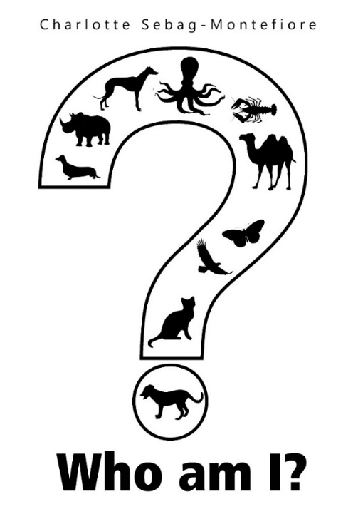
Who am I?
A Book of Riddles
Written by
Charlotte Sebag-Montefiore

Published by Olympia Publishers

25/08/2016 - £4.99 - Paperback

ISBN: 978-1-84897-744-0
In Who Am I? A Book of Riddles author Charlotte Sebag-Montefiore has produced a delightful child's bestiary in verse form. Designed to be read aloud, there are thirty-five poems of five verses each, in which different characters of land, sea and air are depicted, by turns humorous and quirky. In a sixth verse, which is refrain, the young listener is invited to guess the identity of each.

Charlotte Sebag-Montefiore started writing professionally for the children’s website Storynory. She has been writing verse for her friends for years. This is her first book, but Charlotte tells us there are lots more to come...

Press Contact: Chris Hancock publicity@olympiapublishers.com
Tel: 02037553166

