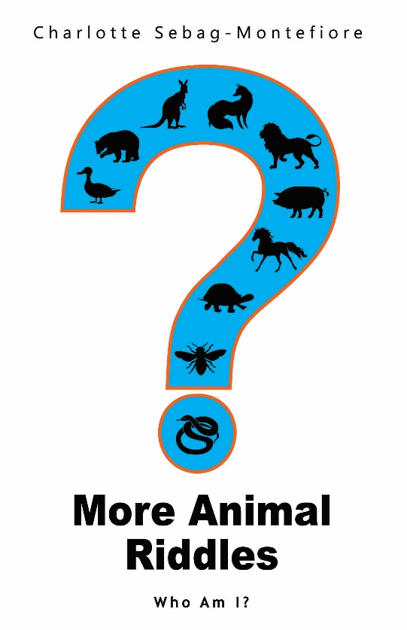
More Animal Riddles -- Who Am I?
Written by Charlotte Sebag-Montefiore

Published by Olympia Publishers

27/09/2018 - £4.99 - Paperback
ISBN: 978-1-78830-060-5
Category: Children’s Book / Riddles

Who enjoys lots of quick giggles but not long, boring journeys? Who needs their fears taken away before lights out? Who is still learning about the world but may find formal lessons hard work? Who makes noise or mischief unless they have better ways to amuse themselves? If you can answer CHILDREN to any of these questions you may be holding in your hands the answer to a riddle faced by many parents. For Charlotte Sebag-Montefiore has penned a book of brain-teasers easy enough for children to read, but not too hard for them to guess. What a gift to parents with bored children to amuse, restless children to keep quiet or with sleepless children with bogeymen to banish. For this is her latest book of riddles for them to solve, and to learn while they

Charlotte Sebag-Montefiore has been writing verse and lyrics for her friends for years. She started writing professionally for the children's website, Storynory. This is Charlotte's second book, and she tells us that there are lots more to come, and that the next one will be very different.
Press Contact: Chris Hancock publicity@olympiapublishers.com Tel: 02037553166

