

Title:
Write your peculiar pet poem here...

PUPIL ENTRY FORM
Name: Surname: Age:

Home Address:
(Please ask your parents’ permission to include this.)

Class: Teacher’s Name:

School Name: Postcode:
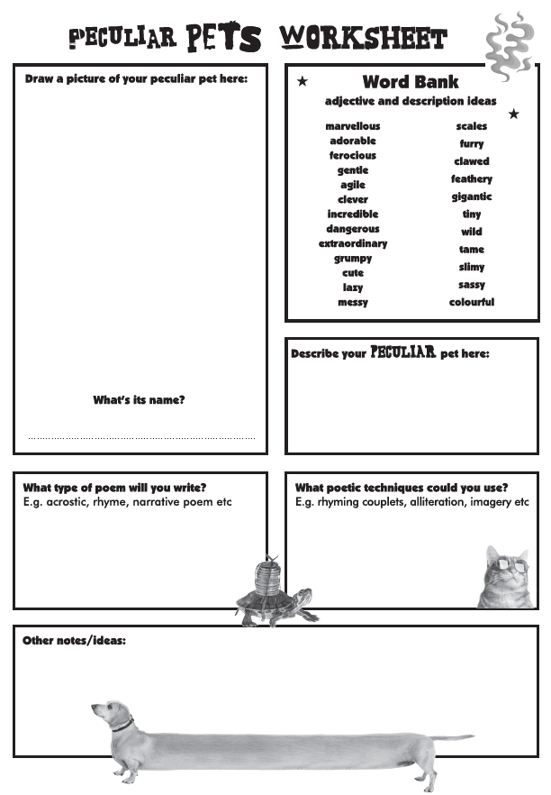
You can use this planning sheet to generate ideas. If you can’t print me you can jot down ideas on a separate sheet of paper.

