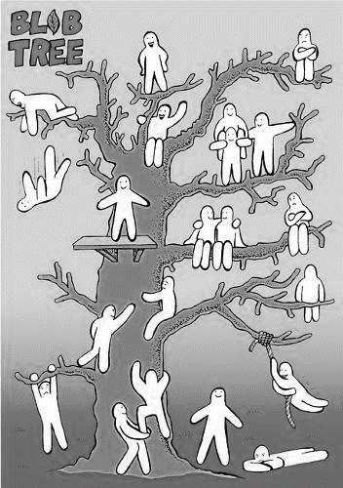
Blob people are used to show feelings, WRITE the feelings you can see around the blob story
In the space below draw your own blob person story, try to show as many feelings as possible.
Blob people have all sorts of experiences and adventures.
Which blob person best represents you? (Colour them a colour to represent you)
How about which one represents your friends? (Colour them a colour to represent them)

Meet the Blob People

