

Miss C says
Make these awesome spider biscuits! This is one of our more advanced “team” projects. Get the kids to help you decorate them and serve them up they are great fun and can be decorated in any way. You will need plain biscuits pre-cooked or co-cooked with your adult we suggest fork biscuits-With only 3 ingredients, the simple fork biscuit is the easiest biscuit recipe for kids, so are the perfect thing for getting busy in the kitchen. The biscuits will keep in an air-tight container for a few days if you want to make them in advance.
INGREDIENTS
100g (1/2 cup) butter (softened)
50g (1/4 cup) caster sugar
150g (1 1/4 cup) self-raising flour
Adult Instructions
PRE-HEAT YOUR OVEN TO 180C / 160C FAN AND PREPARE YOUR BAKING TRAYS. Get your child to line a few baking trays with baking paper.
MIX THE BUTTER AND SUGAR TOGETHER. Get your helper to measure the butter. Ours was a bit hard so we gave it a really quick blast (10 seconds or so) in the microwave to soften it. Put it in a large mixing bowl. Weigh the sugar and add it to the bowl. Beat together with a wooden spoon until it is all well combined.
ADD THE FLOUR. Get your helper to weigh the flour, then add to your mixing bowl. Carry on mixing with your spoons then use your hands to bring it all together into a soft dough
FORM THE FORK BISCUITS Roll small pieces of dough (the size of a walnut or teaspoon) into round balls. Place on your baking tray, leaving space between them for spreading. Dip a fork in cold water and press down on each ball of biscuit dough in turn to flatten each biscuit and make an imprint. If your toddler is too young to help rolling the balls, this is a good step for them to help with instead. Or if you have more than one child helping you, give one the job of rolling the balls while the other flattens them with the fork.
BAKE YOUR FORK BISCUITS. Bake in the oven for 12-15 minutes until they are golden brown.
Remove the fork biscuits from the oven and leave them to cool on a wire rack
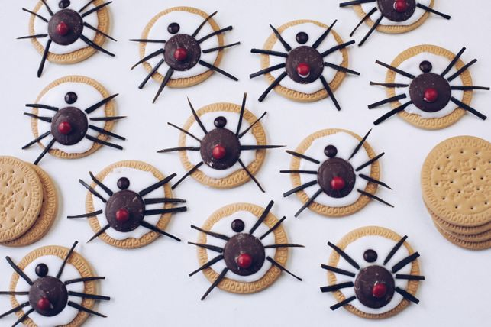
Student Instructions
Decoration-You are on your own now!
- Ingredients
- 12 biscuits
- 1 cup icing sugar
- 3 tbls water
- 55 g milk chocolate buttons
- 12 red mini M&Ms
- 12 brown mini M&Ms
- 2 strap liquorice
What to do
- Sift icing sugar into a bowl; add enough water to make a spreadable paste. This is your icing.
- Cut 24 x 4cm lengths from the liquorice strap and cut each into four strips.
- Spread about a teaspoon of icing onto each biscuit. Place a chocolate button on top of the biscuit and use a little bit of icing to stick a red M&M on top.
- Stick a brown M&M in front of the red back. Stick four liquorice legs on each side of the spider body. Allow the icing to set before serving.

