
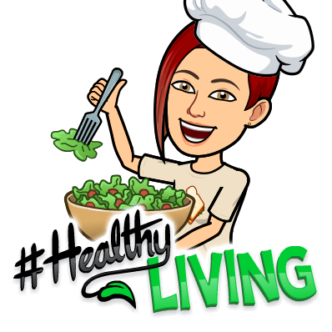
Open Sandwich Fun
Have fun with food together with an afternoon tea complete with easy, open- sandwiches featuring a variety of toppings
Miss C says
Open-faced sandwiches or Smørrebrød are probably the best sandwiches you will ever eat, easy to put together, yet impressive in appearance, so versatile and incredibly delicious.
They can contain whatever fillings you prefer and you can get really creative blending tastes.
Bread with butter, smør meaning butter and brød bread in Danish is the two main elements of an open sandwich. But it doesn’t stop there, just a bread with butter would be rather boring.
The things you can top your open-faced Danish sandwiches with… is a never-ending story.
A traditional Smorrbrod sandwich idea
Havarti cheese and tomato:
The simplest version and the one I like best, the kind of smørrebrød; I make every day without even thinking of it as being a smørrebrød.
Bread with butter, topped with Havarti cheese and tomato slices.
- Butter your bread
- Add your cheese. If you cannot find or don’t like Havarti, you can use any kind of sliced cheese you like instead: Gouda, Cheddar, Esrom, whatever really.
- Add your accompaniments. Some lettuce and some crunchy spring onion rings elevate this regular cheese sandwich, making it something really special.
Another loaded & open sandwich idea
Student instructions
- Trim the crusts from the bread if you like and cut each slice into smaller pieces. Spread each slice with butter and lay out on a board.
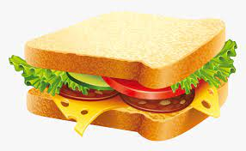
- Mix 2 tbsp mayonnaise with the cucumber shreds/cucumber relish and spread over a quarter of the buttered bread slices.
- Arrange the ham and the radishes over the top.
- Spread the cream cheese over another quarter and arrange the cucumber and dill on top.
- Mash the egg (I boiled egg you can get an adult to do this in advance and it will need to cool) with 2 tbsp mayonnaise
- Spread over another quarter, then top with the cress.
- Mix the prawns (or other toppings) with the remaining mayonnaise and Spoon over the remaining bread slices, then grind over a little black pepper.
- Add a garnish of dill, if you like.
Miss C’s tip-tbsp. stands for table spoon which is the larger serving type spoon.

