
Ready Veggie Wraps
Miss C says
For this Veggie Lunch Wrap Recipe, You start with a soft tortilla. If your tortillas break easily when they are rolled, a wrap won’t be easy to make.


Then, we spread a layer of cream cheese on the tortilla. I like cream cheese for wraps, because it sticks the entire thing together, without the use of toothpicks or ties. Spread the cream cheese to the very edge of your tortilla, and it will work like glue.
Then, layer three (or as many as like) different veggies on the wrap. First, shredded carrots. Then, cucumbers sliced super thin! I use a cheese grater to get them super thin. If they aren’t thin enough, rolling the wrap is difficult.
Then, we added some shredded lettuce to the very top.
You can add, dice, shred or tear anything you like to make your wrap special.

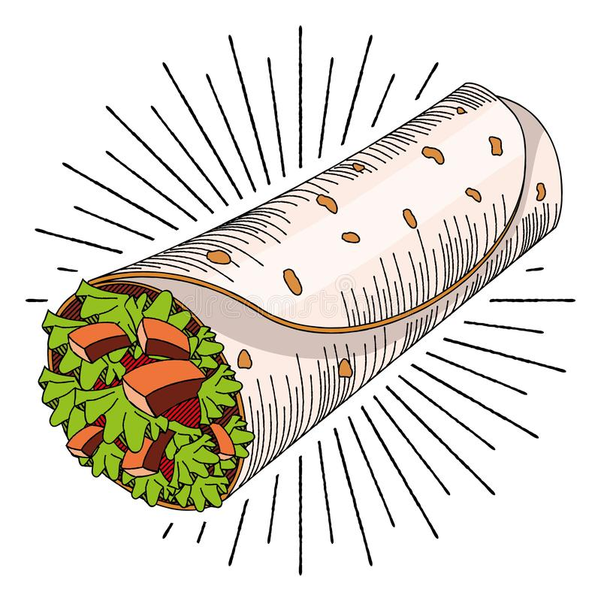
Now, you roll it! At this point, I usually wrap them in some plastic wrap and put them in the fridge until we are ready to eat. Even just 30 minutes or more chilled will help keep the wrap nice and sealed and will keep its shape.

Summary
Ingredients
- 4 medium tortilla, whole wheat
- 2 tablespoon cream cheese, low fat
- 1 medium carrot
- 1 medium cucumber
- 1 cup lettuce, shredded
Instructions
- Spread 1/2 tablespoon cream cheese on each tortilla.
- Grate carrot and sprinkle on each tortilla.
- Slice cucumber super thin, using a veggie peeler or mandolin.
- Arrange cucumber slices on tortilla.
- Finally, shred the lettuce and divide among each tortilla. Wrap up tightly.
- Cover each wrap with plastic wrap and keep in the fridge to chill and hold its shape.

